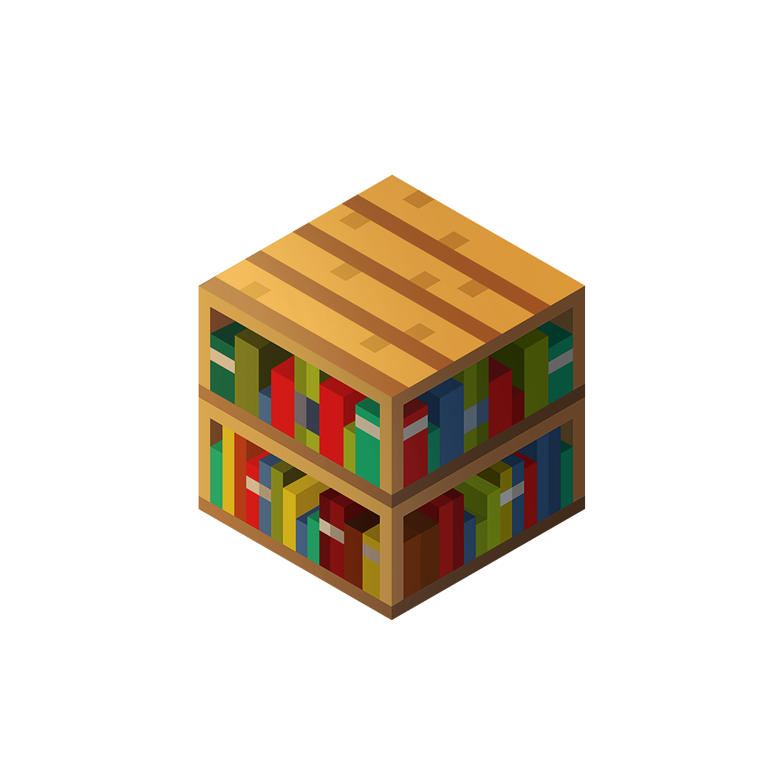


:::

Building a Better World Through Play

First Lesson Kit

Everything you need to Get Started

Introduction
First Lessons Kit with Minecraft assist educators who are new to Minecraft: Education Edition.
Throughout this notebook, educators will explore the concept of game-based learning and explore how to plan standards-based instruction utilizing Minecraft: Education Edition.
To help you get started teaching with Minecraft: Education Edition, we’ve compiled some key resources – including a sample digital citizenship lesson, social contracts, starter worlds, training videos, and connections to other Minecraft educators to make the implementation of Minecraft in your classroom as smooth as possible.
The graphic below is a visual representation of the learning progression for you, the educator. Following this plan may help you to incorporate Minecraft: Education Edition into your classroom.

Getting Started: LEarning to Play Minecraft
You may not have played Minecraft before and you may be concerned that your students will know more than you. Don’t worry, many educators before you have overcome this challenge.
Firstly, it is quite possible that students will know more. Celebrate this and encourage them to help you learn. They will love teaching and demonstrating to you how to do things. Many Minecraft educators talk about the positive impact this has on their classroom. Secondly, you can quickly get up to speed with skills in Minecraft with these following short videos.
Video | What does it cover? | How much time do I need?
Getting Familiar with Minecraft  https://youtu.be/BrSweFC3XUY | Explores all that the application has to offer: skins, game settings, worlds, the lesson library, and more! | 3’ 38”
Basic Controls in Minecraft  https://youtu.be/mcmYMb67HI0 | Learn how to Move, Jump, Fly, and Place and Break Blocks in Minecraft: Education Edition | 2’ 42
Using How to Play Tutorials in Minecraft  https://youtu.be/hieMlK9cKoM | 6 new user how-to play tutorials, you will learn how to move, break and place blocks, and use in-game assessment features. | 0’ 55”
Add a Resource Button to a Minecraft Education World  https://youtu.be/wcSKyVUo8Nc | Create a custom button when assigning a lesson from the Library that links to a Flipgrid topic, Microsoft Forms quiz, or any web tool. This Resource Link button appears on the Pause menu when students create the world. | 3’ 30”

Controls for Minecraft
Use the following chart to remind yourself of the Minecraft controls.

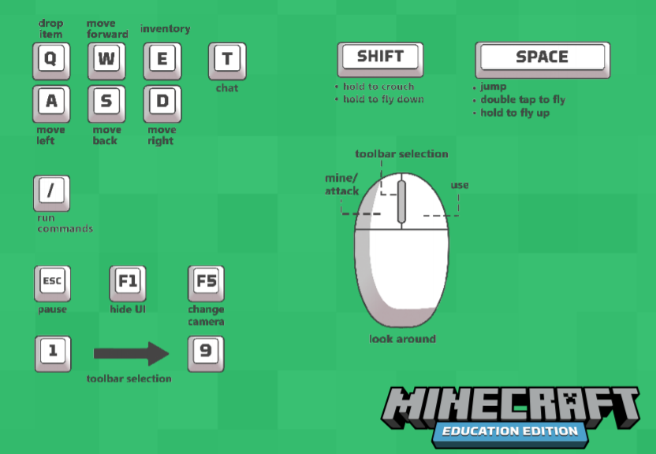

Getting Started: Teacher Playing Minecraft
One of the easiest ways of you practicing Minecraft Education Edition is to complete the New User Tutorials.
The New User Tutorials teach Movement, Breaking and Placing Blocks, Interaction, and in-game Assessment features. The 6 New User Tutorials should take around 1 hour to complete, and each tutorial has a companion video for additional support, which can be found by selecting a tutorial, and clicking on the “play” button on the upper-left hand corner of the screen:

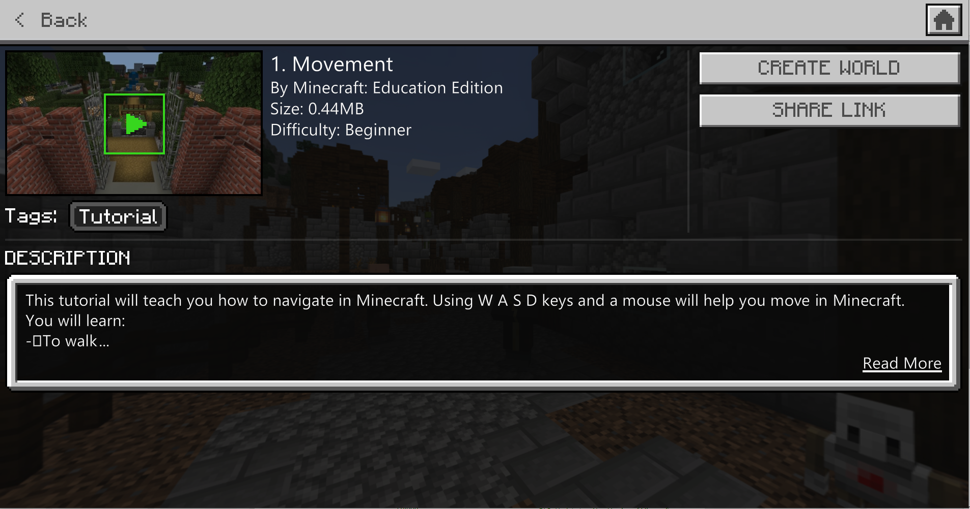

Download the game (if you have not yet done that) https://education.minecraft.net/get-started/download/
Launch the game and sign in with O365 Education account.
Click “Play"
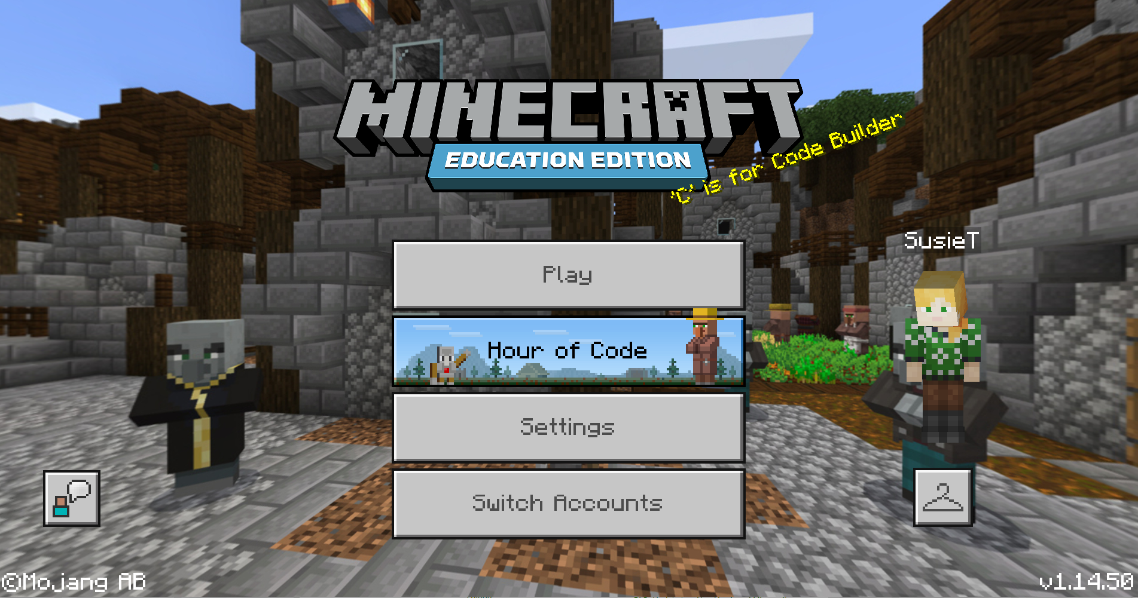
Click “View Library”
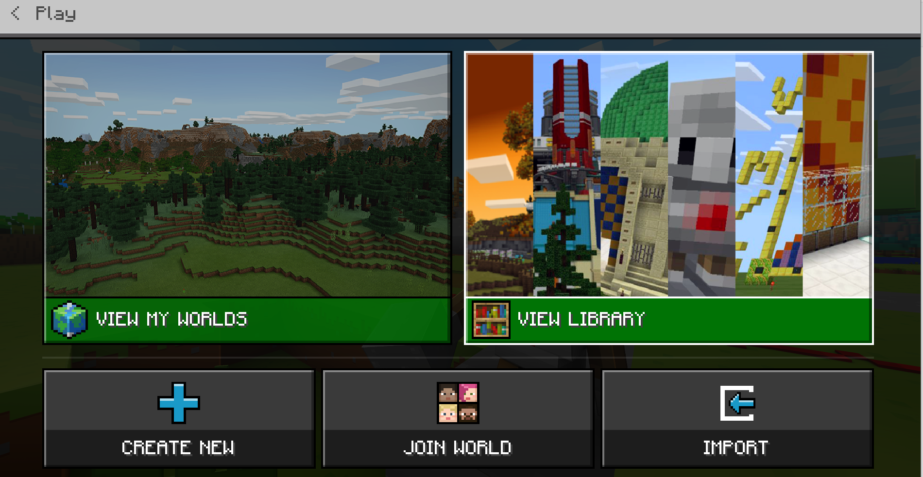
Click “How to Play”
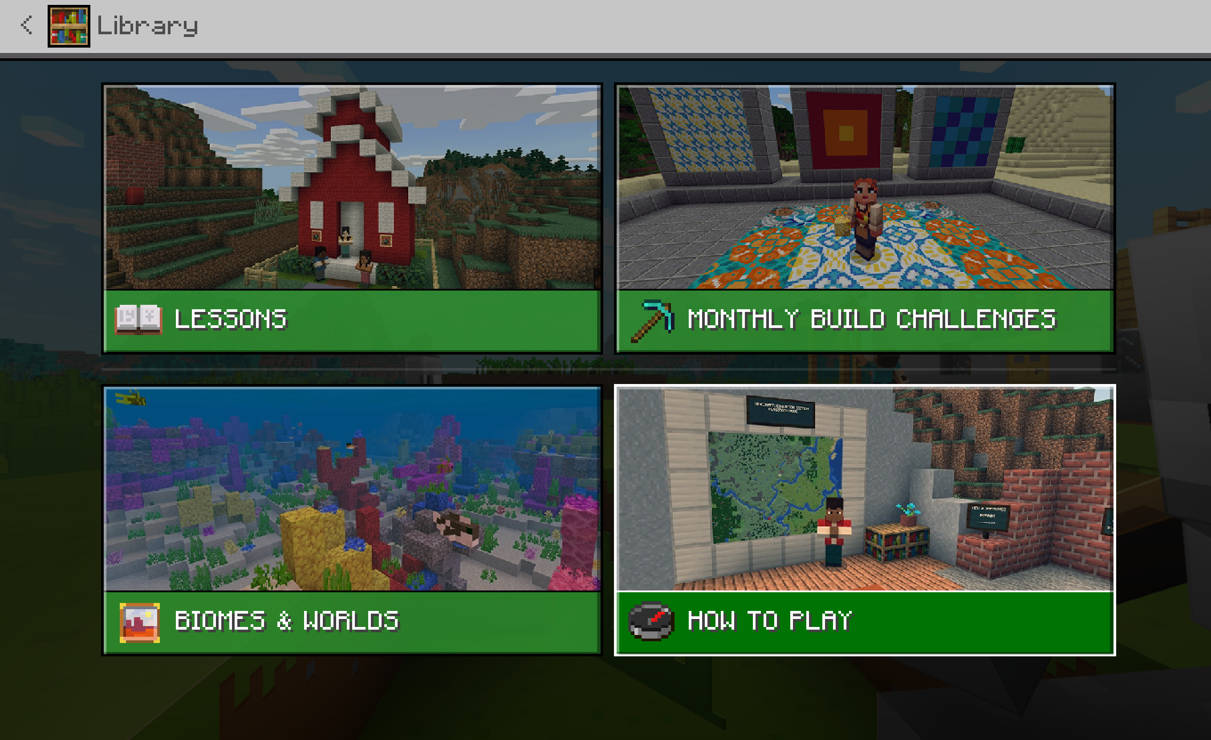
Click “Start Here”
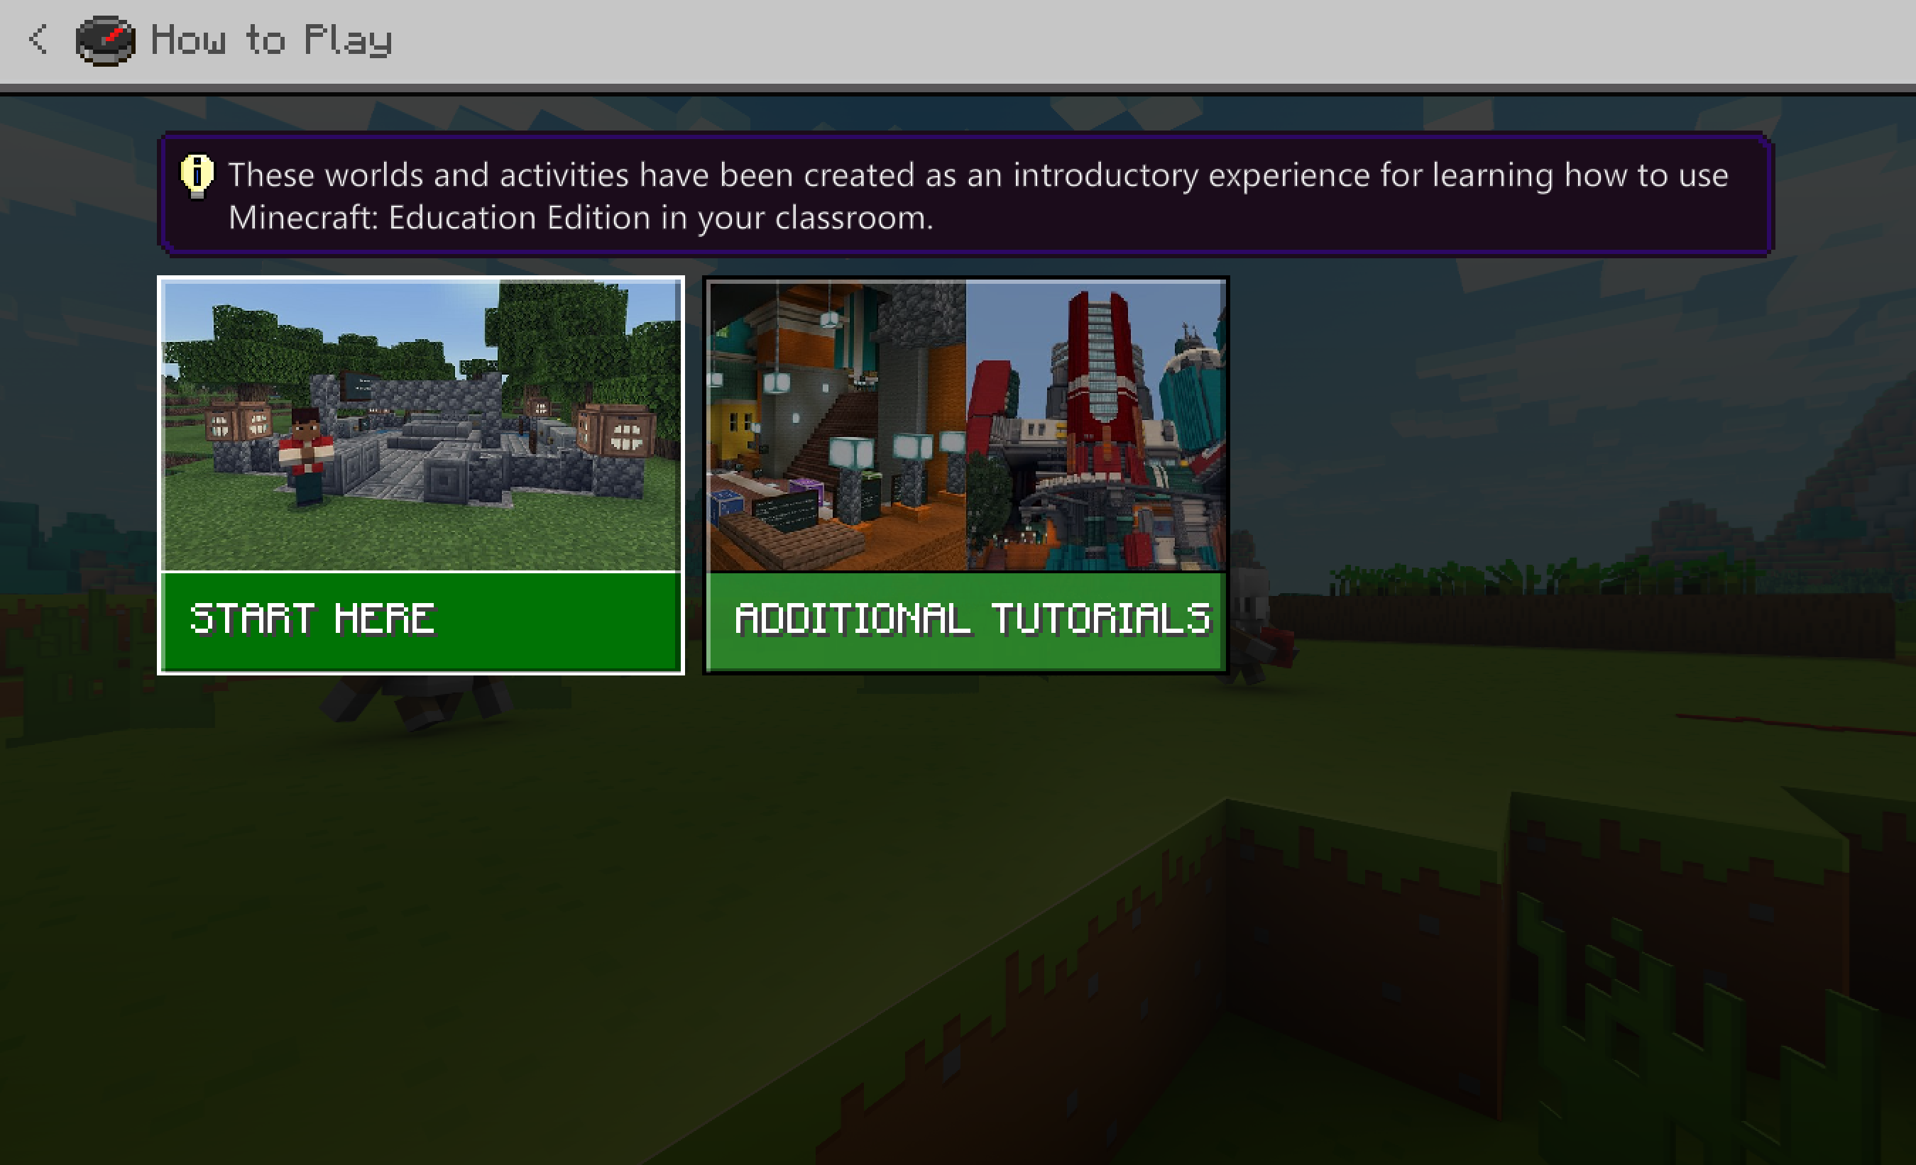
Select “1. Movement”
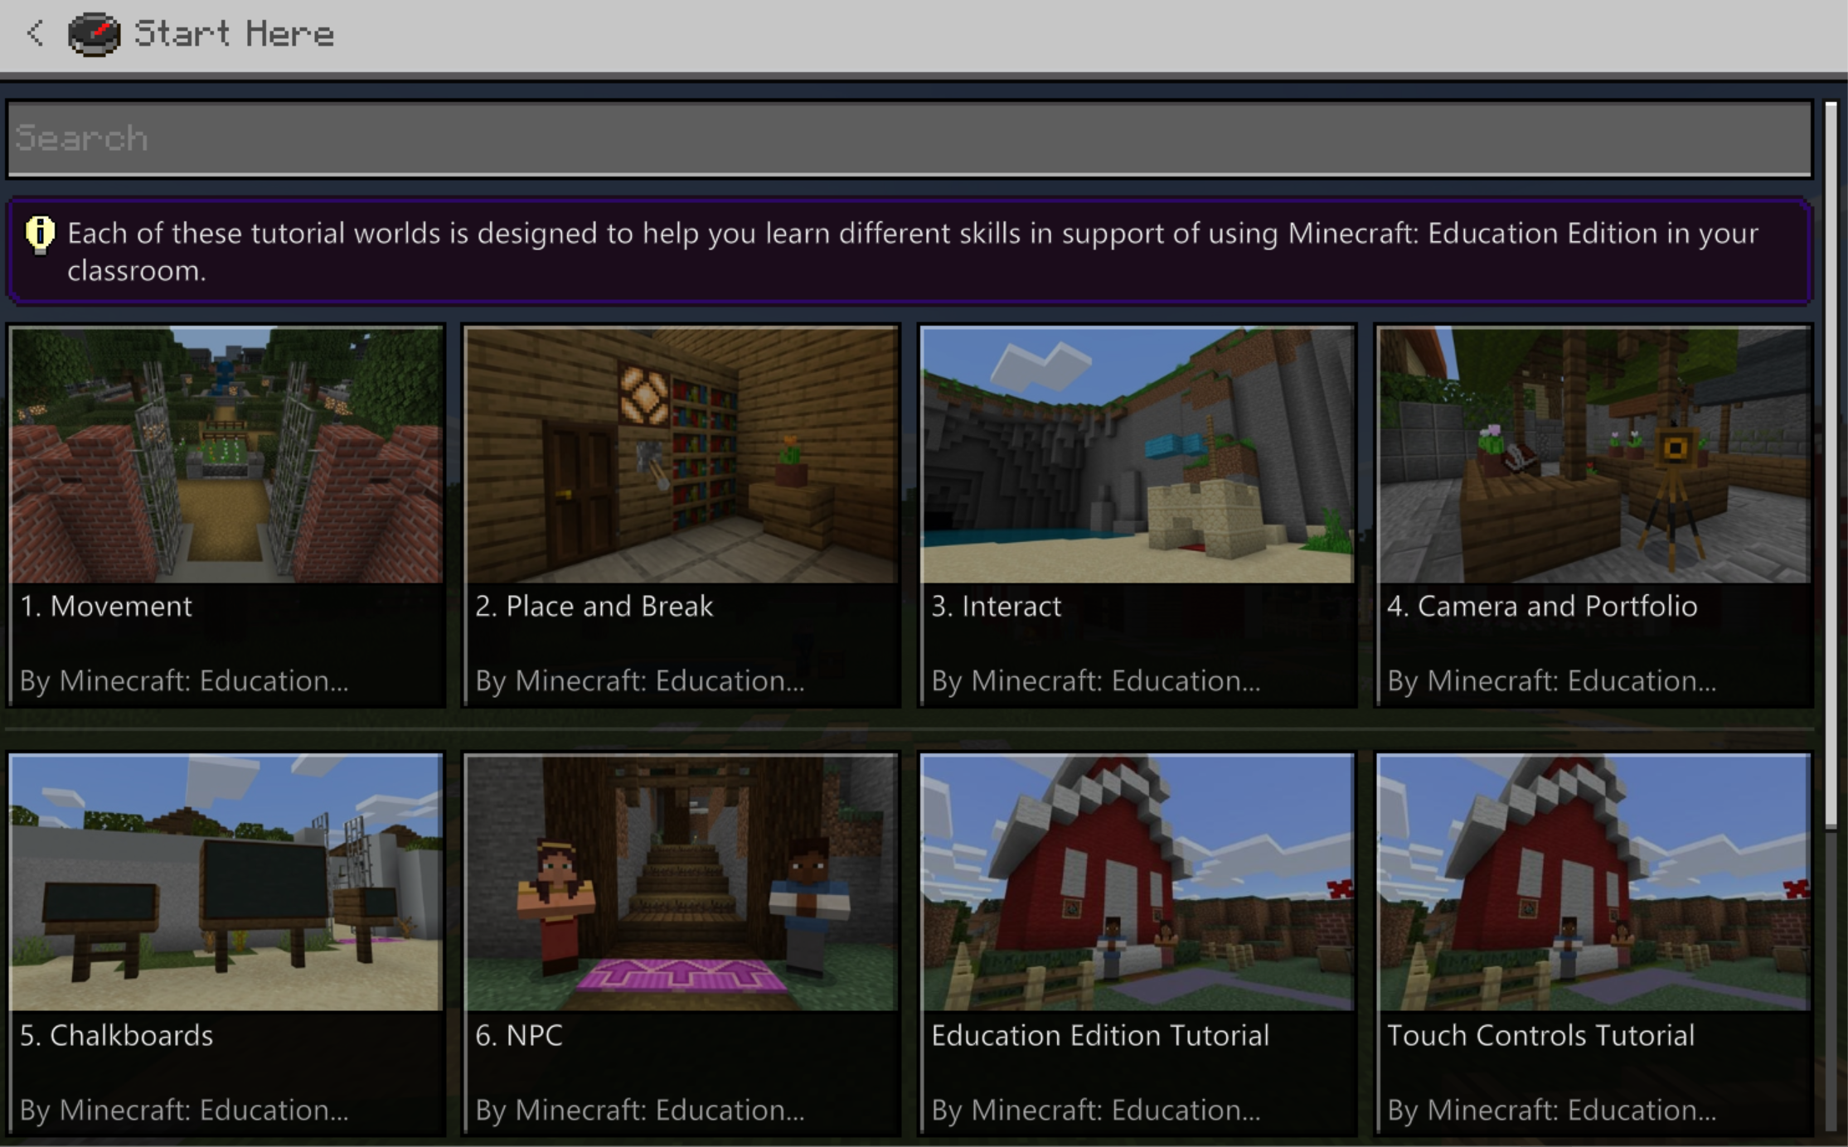
Click “Create World” and complete tutorial.
Complete tutorials 2-6: (Place and Break, Interact Camera and Portfolio, Chalkboards, and NPC) – Now you are ready to go to the classroom.

Setting up your Classroom for Success
We have developed lessons that walk you through an existing lesson and ending with a template for you to use to design your lessons.
If you just started with Minecraft: Education Edition in your classroom for the first time, it is best if you…
- Treat a lesson with Minecraft: Education Edition like any other lesson that has set routines.
- Allocate more time for logging in and starting (at least 10 minutes for the first time) when planning a lesson.
- Think about the way you will share content/world/instructions with your students in advance.
- Have an introductory session with students to go over the rules and how they will use Minecraft in the classroom vs. at home.
- Even if all your students say that they have played Minecraft before, it is a good idea to refresh their memory and go over some classroom rules. Some students are shy or don't want to lose their face by admitting that they don't know how to play, so it is best to start from "ground 0."
- Introduce several gestures that you will be using to manage your classroom.
- Gesture 1 - to get students' attention
- Gesture 2 - to get everyone to close laptops or stop playing
- Gesture 3 - "I don't understand how to complete the assignment/task."
- Gesture 4 - "I have a technical issue."
- Pair students based on their performance in Minecraft after the first session, so that they can help each other out during the activity.
- Set the time from the beginning and be strict about implementing this rule. You will always have students asking for extra time.
- Have a clear and realistic objective in mind of what you want to see after using Minecraft. Make sure you set students' expectations as well. Some students can be perfectionists. They need to understand that they need to achieve the goal first and then perfect it as they wish later.
- Don't skip the planning time with your students. The planning stage is essential for them to achieve the goal.

SET UP STUDENT ACCESS
Before you start your first class you will want to run through this list as a pre-flight check:
- Is Minecraft: Education Edition installed on ALL machines being used?
- This is where you are checking for possible missed machines.
- Note all machines that do not have Minecraft: Education Edition installed.
- To solve issue: Follow installation procedure with your IT Admin. Can you install it quickly yourself or do you need to put in a help request? If a help request is necessary, wait until after Task 2 is complete to put in the request since you will need to add missing student license information.
- Pair students up with another computer so that you can continue to move on to Task 2 to check for log ins.
- Can ALL students log in?
  - Have all students attempt to log in.
  - Students who can log in can help struggling students.
  - Paired students should log in and then sign out and let the other student log in to check that their log in works.
- Note ALL names and log in information of students that cannot log in and share that information along with the installation request you did above.
Management Tip: It will be frustrating for students not to be able to log in. Share with them that therefore you are checking this information. You want to make sure all students can get into the game before you assign a task for learning. Once you have all log in information ready to go, move on to Lesson #1.

First Lesson: Creative Exploration
Total Time: <60 min
In this lesson students explore a basic Minecraft world. This lesson is great to help new players get used to controls.
Activity 1: Logging into Game
2-5 min
Start the game from the start menu
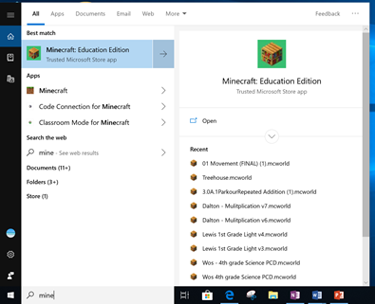
Log in using the student’s account
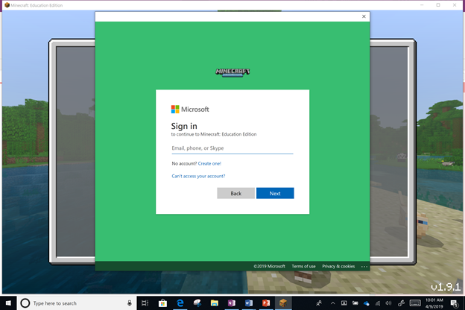

Activity 2: Changing Skin
10 min
Changing Skins:
- Allow students the opportunity to look over the available skins.
- Have them change their skin to reflect themselves.
- Have students note what skins are available to them in Minecraft: Education Edition.
- Have them discuss with a partner or table group what skins are available in Minecraft: Education Edition. Ask them how they could see using some of the skins in class. Do some of the skins match current topics they are learning about?
- Have them press Confirm.

Select the skin icon
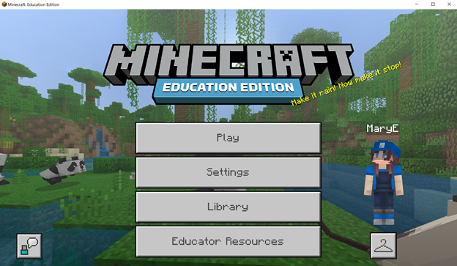

Choose a skin
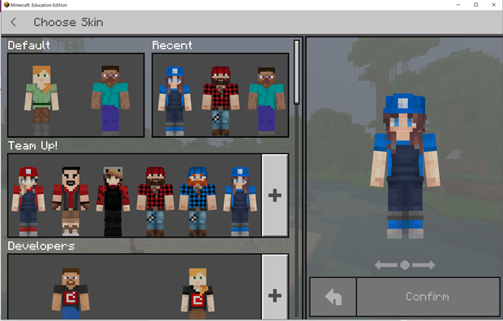

Activity 3: Opening a World and Changing Game Settings
2-5 min

Opening a World Template:
- Have student select 'Play'.
- Have students select 'Create New'.
- Have students select Blocks of Grass Template.
Once in Blocks of Grass Game Settings:
- Have students choose Creative Mode.
- Have students select the difficulty level to be Peaceful.
Changing the game settings to Creative Mode and the level to Peaceful allows students to build free of threat. A teacher would select this so that the building takes center stage over the surviving. These can be switched back and forth at any time.
Select Play

Activity 4: Creating a House
15-20 min

Have students create a house. This is an easy way for you to assess the levels in your room.
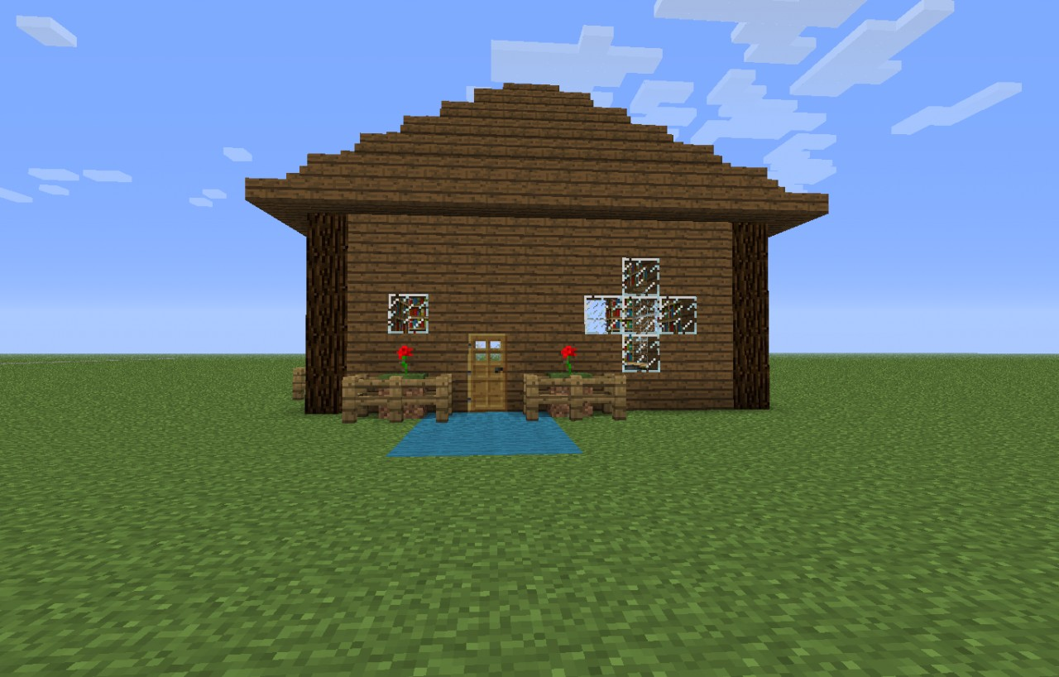
You will be able to tell:
- Who is a proficient builder.
- Who is new to the game.
- How your class interacts when you introduce Minecraft: Education into your classroom.
You should be doing these things while your students build:
- Walk around and listen to what students are saying.
- Watch what they are doing.
- Let them help each other.
If a student asks you how to do something, open the question up to other students. You do not need to answer their questions.
What kinds of collaboration do you see happening? How are students interacting with each other and which students are the most engaged?
Management tip: You can have them build for as long as you have time. Make sure you give time notifications throughout the build so that students can manage their time. You will also be able to note who will have more challenges when it comes to transitioning out of the game.
Blocks of Grass ‘Spawn’ or Start
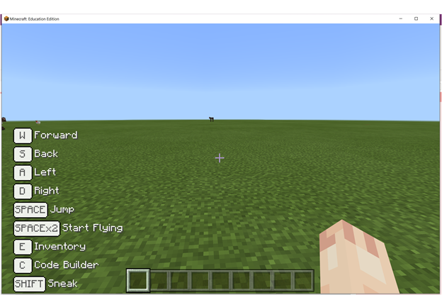

Activity 5: Student Share Out
5-10 min

Provide your students with time to reflect and share their builds at the end of each activity when using Minecraft: Education Edition. Students take great pride in their builds, and they connect with their work on a deep level.
Have students turn their computer screen toward each other, in table groups, and share what they built and why they chose the materials they did.
Give students a time limit so that all students have time to share their build.
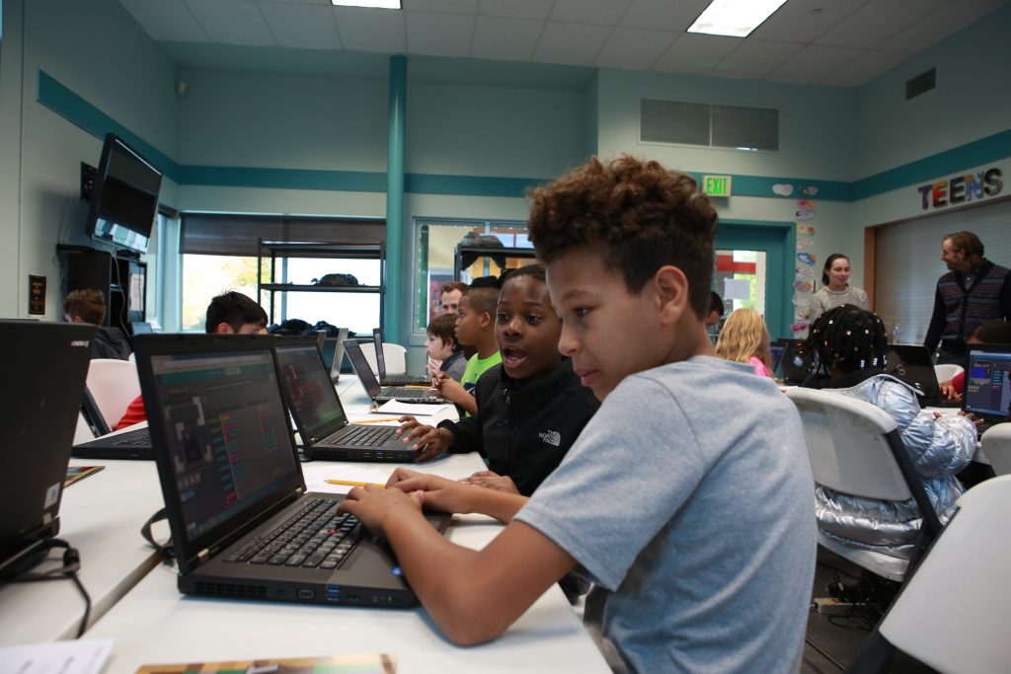

Vocabulary Guide
The language in Minecraft might be new to you. So here is a simple reference to terms you might come across.
Agent
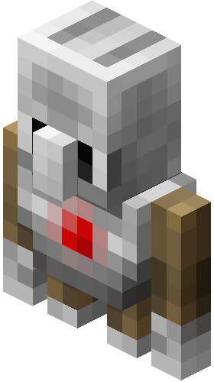
A non-playable character that is a player's helper when using computer coding in-game. The agent will follow the commands input by the student and carry them out in-game. For instance a student can have their agent build an entire structure or farm for resources.
Biome
Biomes are regions in the Minecraft world, such as jungles, forests, and deserts. Biomes have their own climatic and environmental features, including rain cycles, variations in grass or plant life, and even geographical structures, such as rivers and mountains.
Blocks
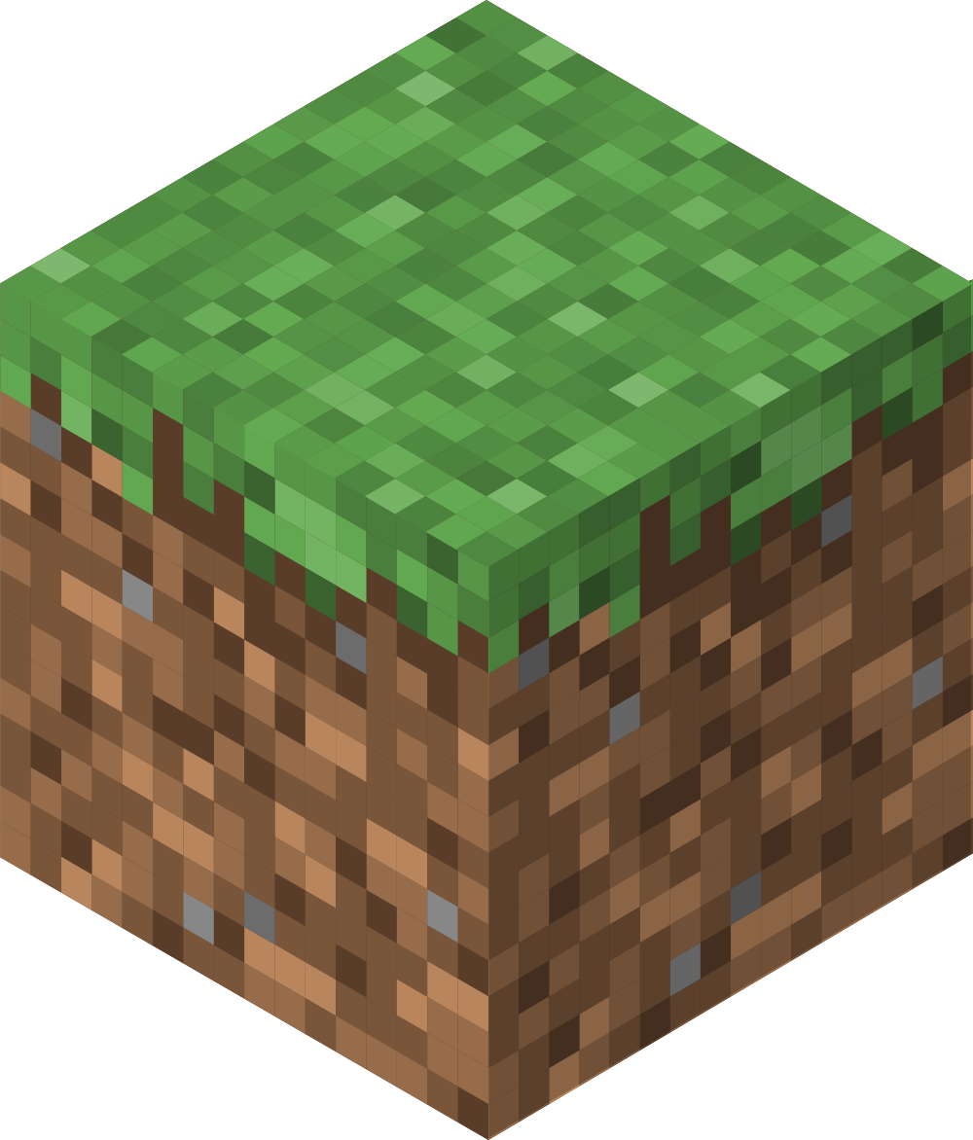
The basic units of structure in Minecraft. Each block measures 1 cubic meter for solids or 1000 liters for liquids.
Game Modes
Creative:
The creative mode lets players build anything they want from an endless supply of blocks and renders them invincible from would-be enemies.
Survival:
The survival mode, by contrast, is the standard game mode wherein players have to collect resources, fight mobs, and explore -- all with the goal of staying alive.
Adventure:
Adventure is a restricted mode primarily for completing learning experiences without the ability to place or destroy blocks. Players can only move and interact with levers, buttons, and other similar items.
Griefing
The act of irritating and angering people in video games. This is done through constructing offensive builds, destroying other players builds, bullying in game, etc.
Multiplayer Experience
More than one student interacting in the same world.
Single Player Experience
A student interacting alone within one world.
Skin
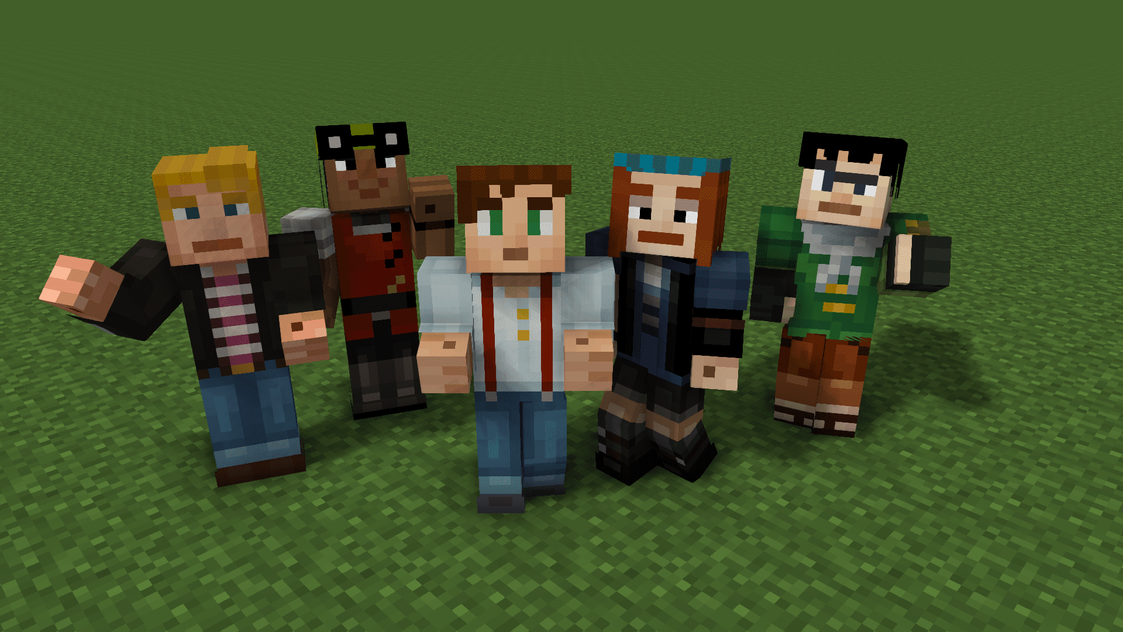
A skin is an image that determines what your character looks like in the game.
Tick
The measurement of time found in Minecraft. Time moves much faster in-game than in the real world. For example, one "day" in Minecraft lasts 20 minutes in real-time.
World
Randomly generated combinations of biomes comprise a world file for the student to work in. Worlds can be infinitely flat or mimic terrain found in biomes such as jungle, tundra, or desert, etc.

Getting Started: Coding Tutorial for Teachers
If you plan to use Minecraft to teacher Coding, you may want to complete the coding tutorial.
If you would like to practice coding in Minecraft, use these 2 exercises:
In the Library, select “How to Play”
Select “Additional Tutorials”
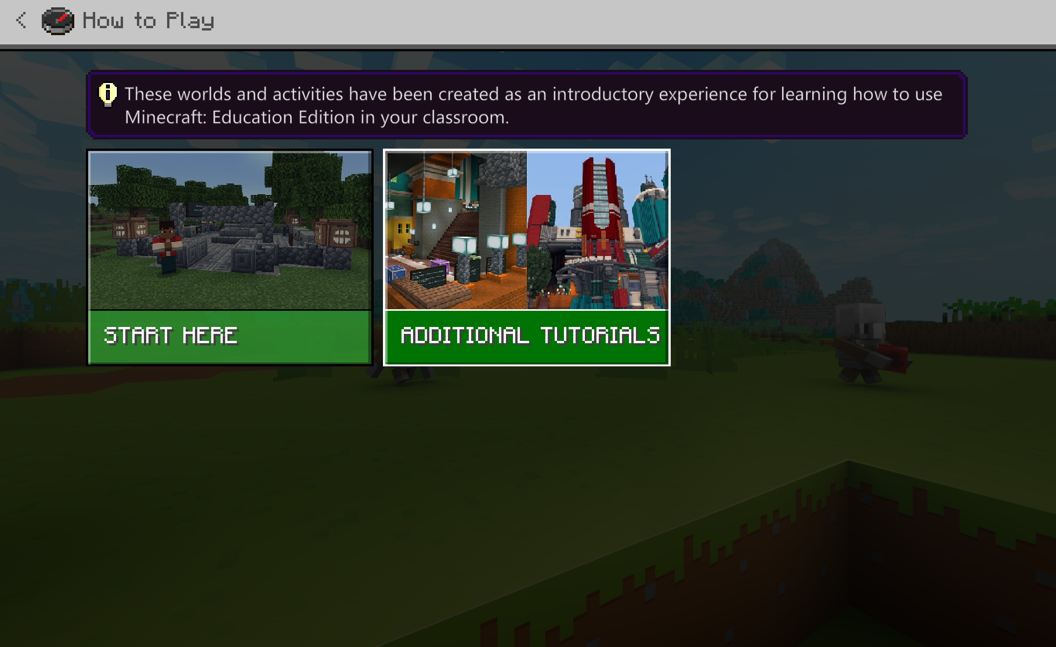
Select “Code Builder Tutorial”
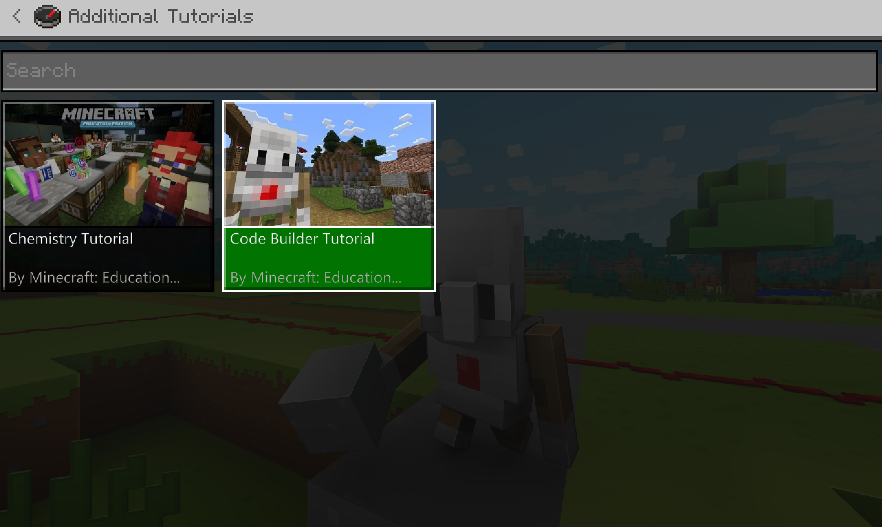
Click “Create World” and play through agent trial activities.

Getting Started: Block Coding for Teachers
There are also tutorials built into Makecode (A block coding environment). If you are taching coding to primary or middle school aged children you may wish to use this.
Click “Create New”
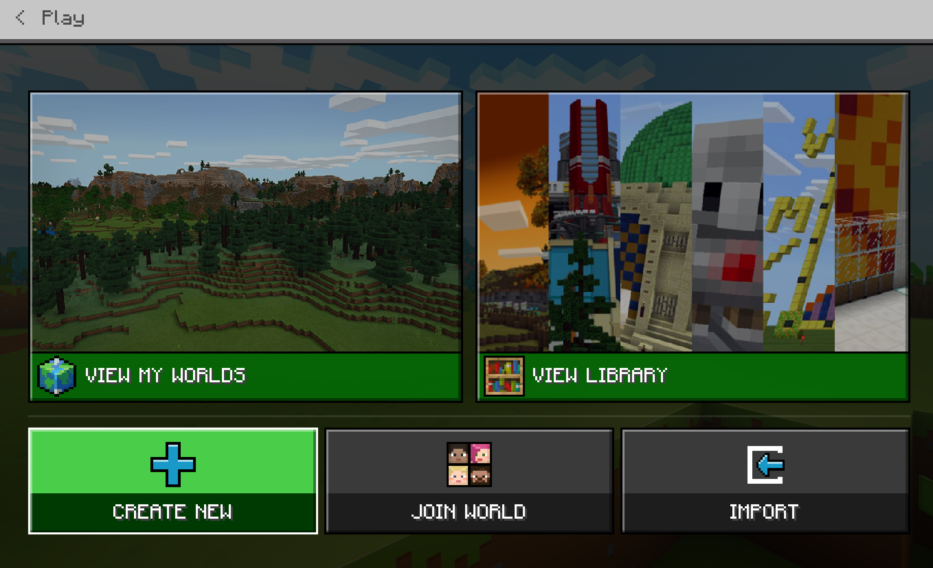
Click “Templates”
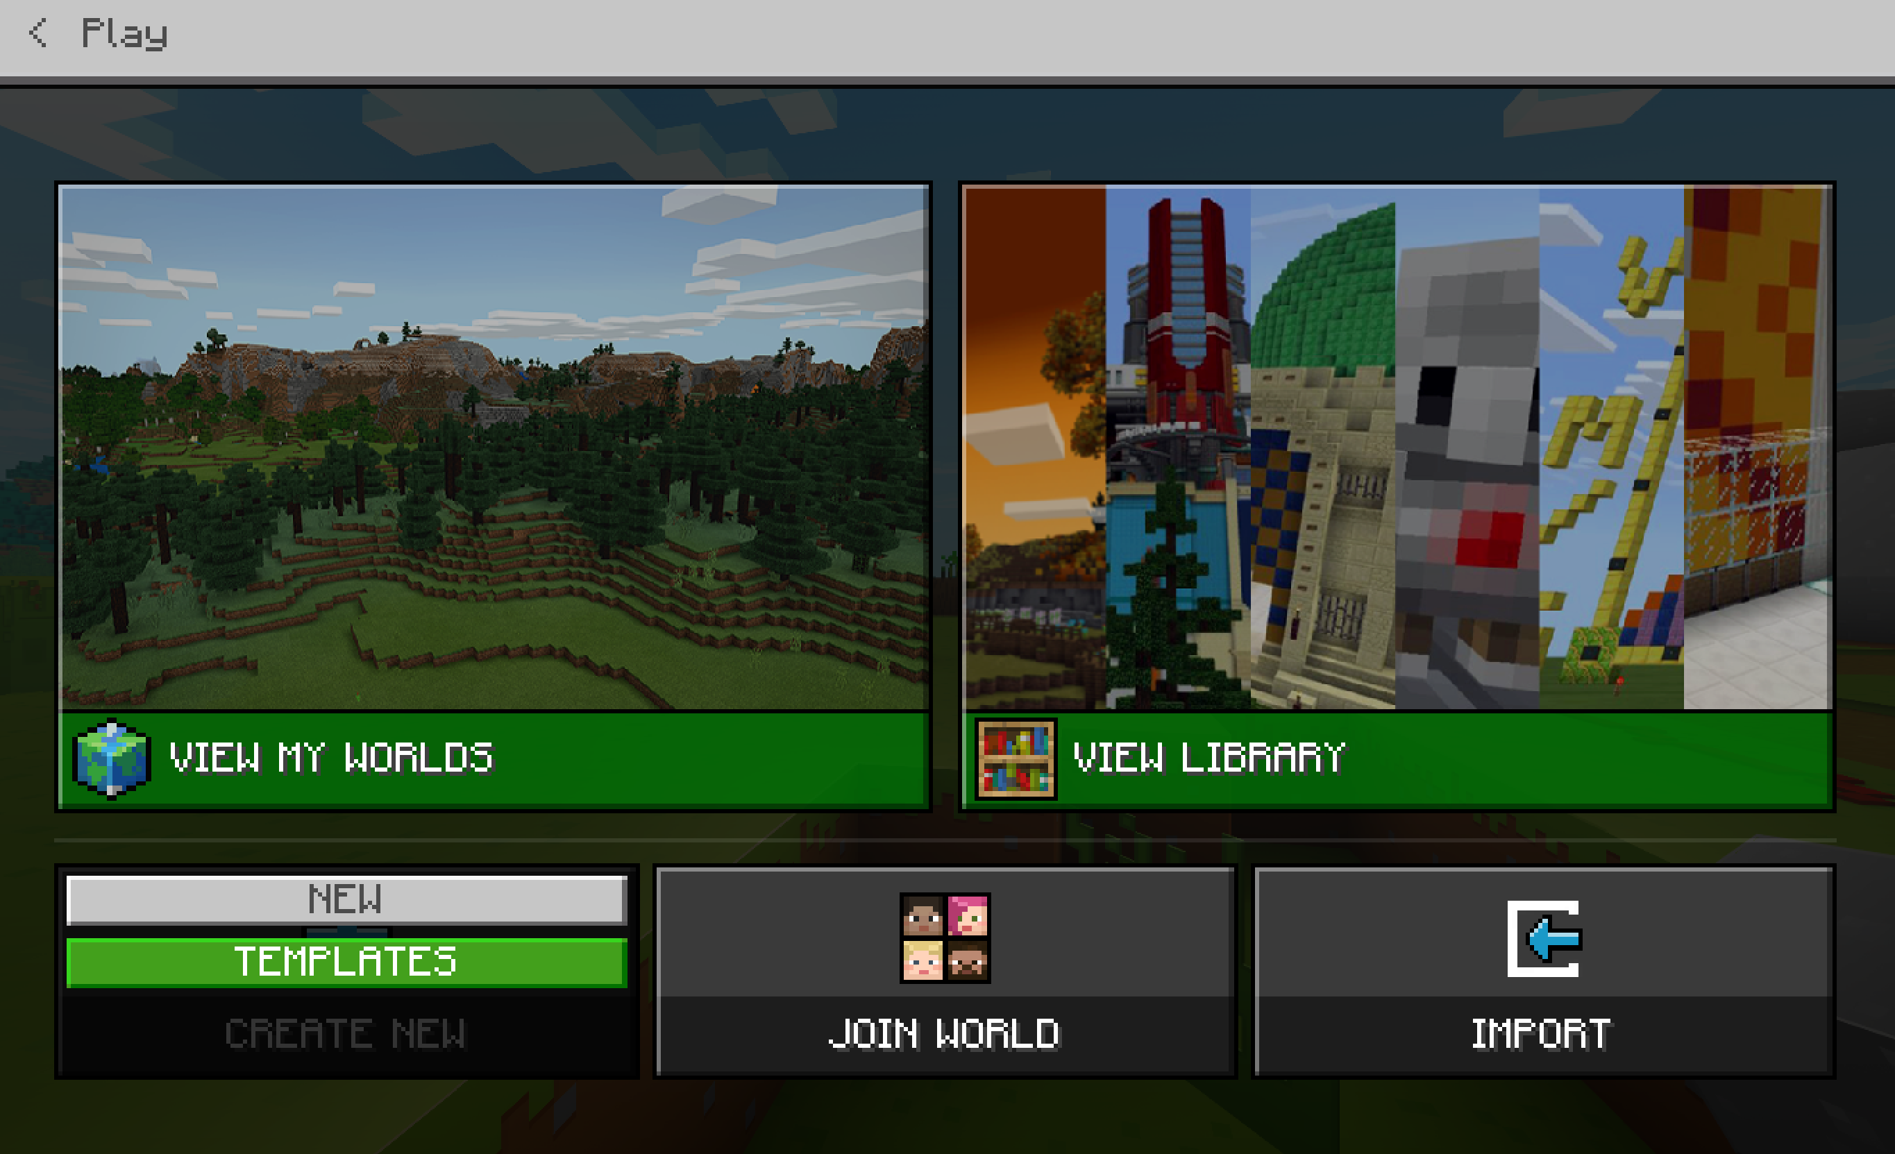
Select “Blocks of Grass”
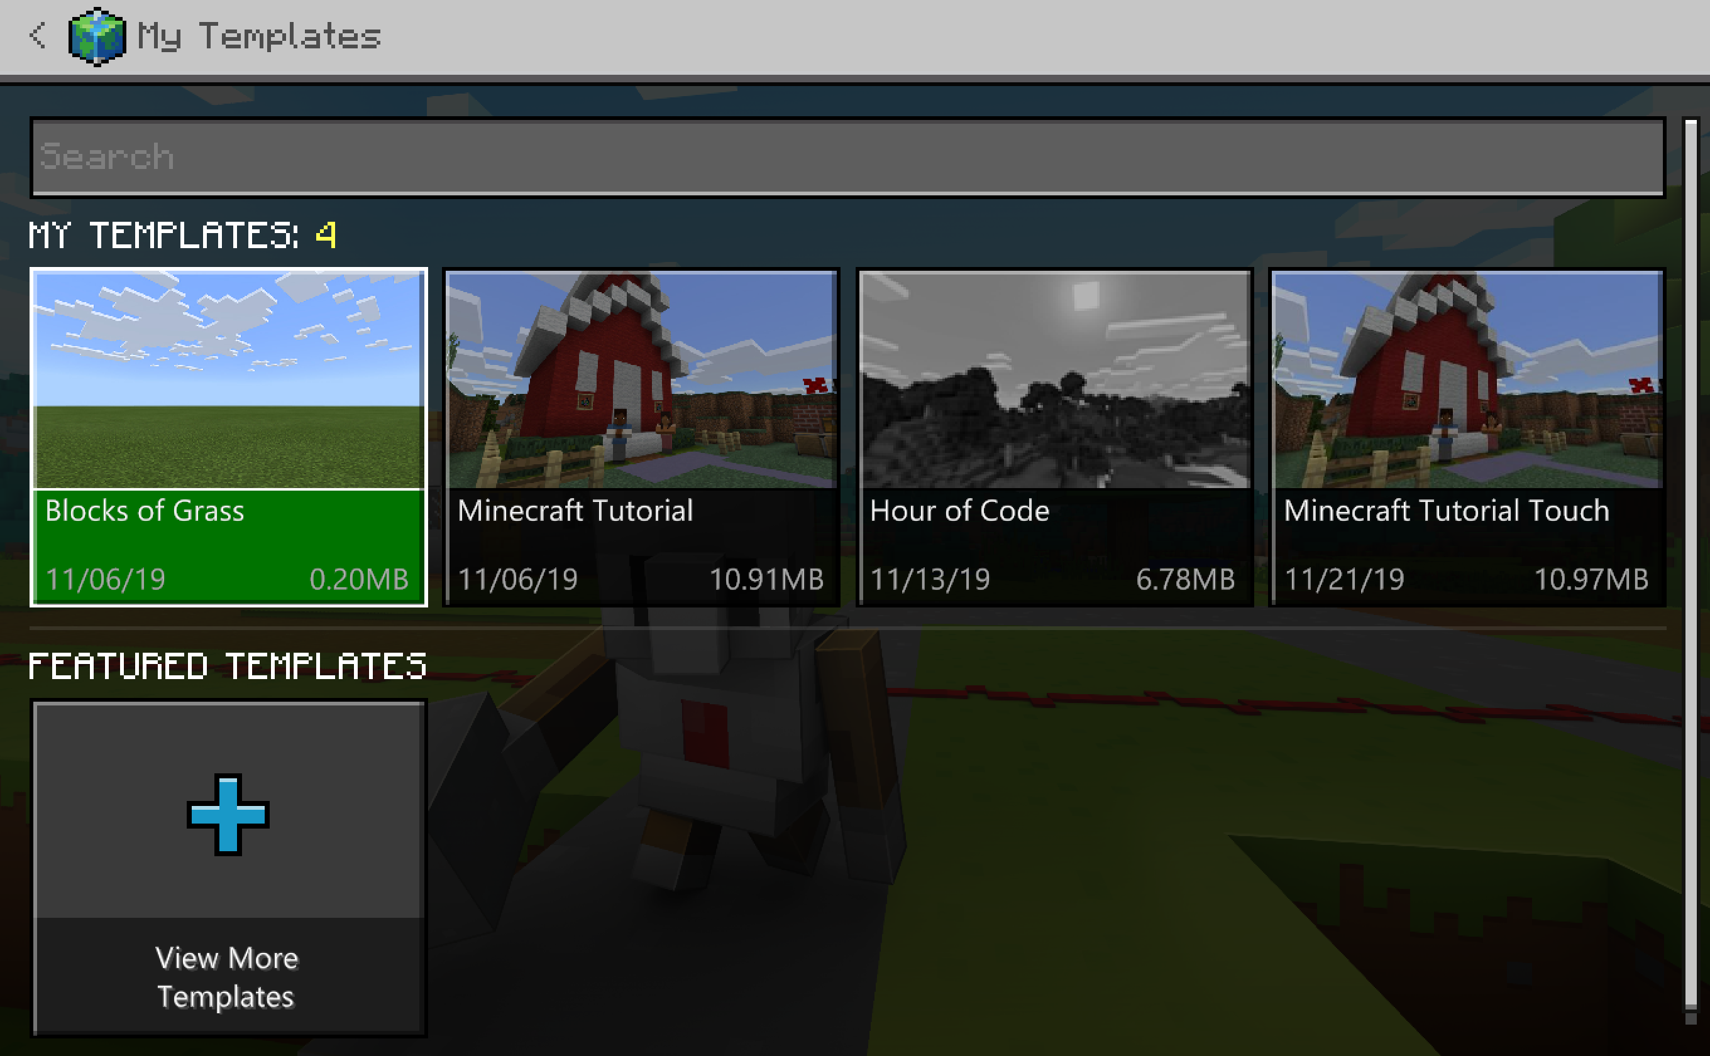
Click “Play”
In the Blocks of Grass world, press the key “C” on your keyboard to launch code builder
Select “Microsoft MakeCode”
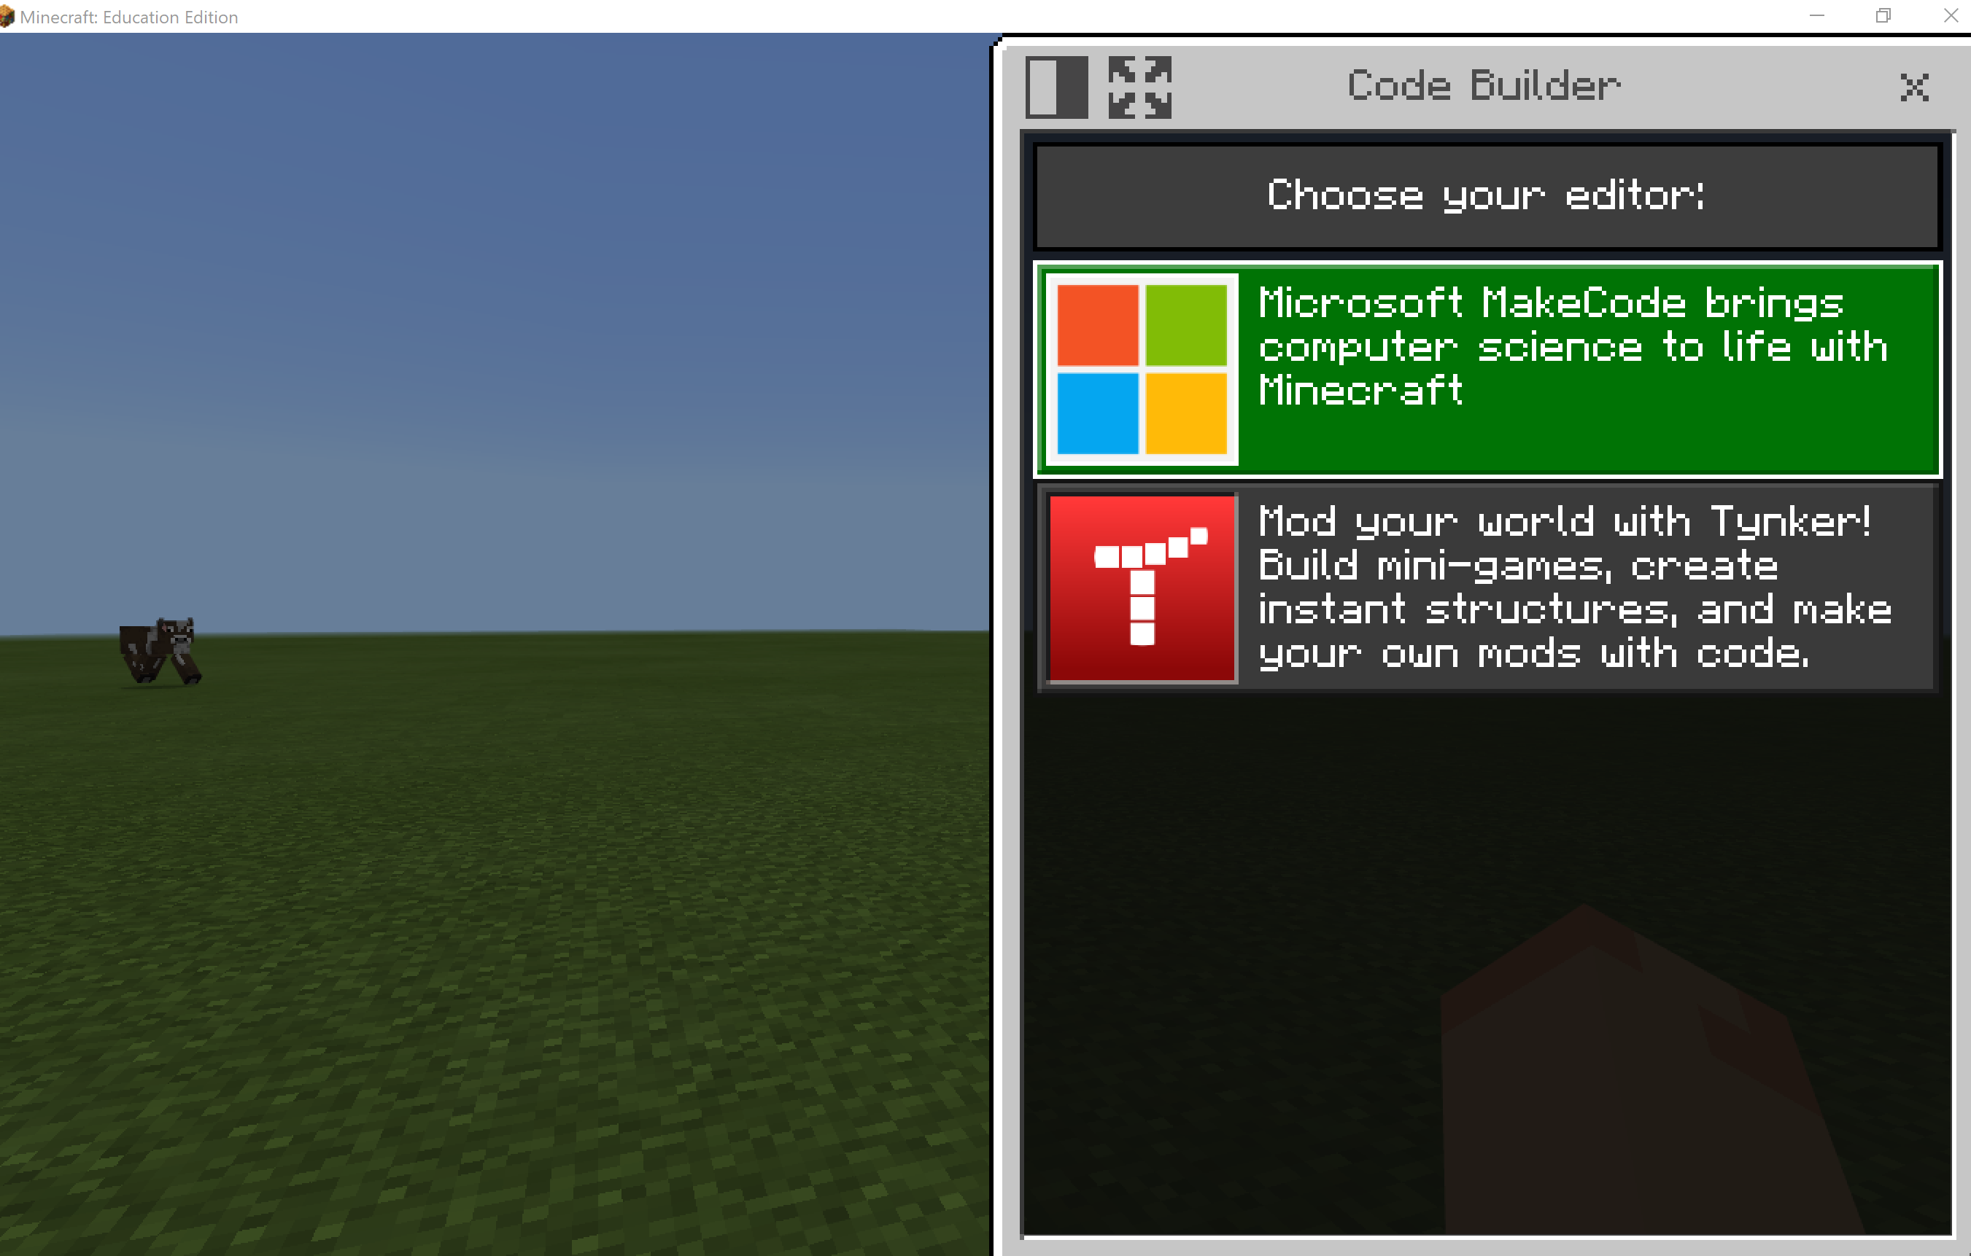
Under “Tutorials”, select the first option, “Chicken Rain”
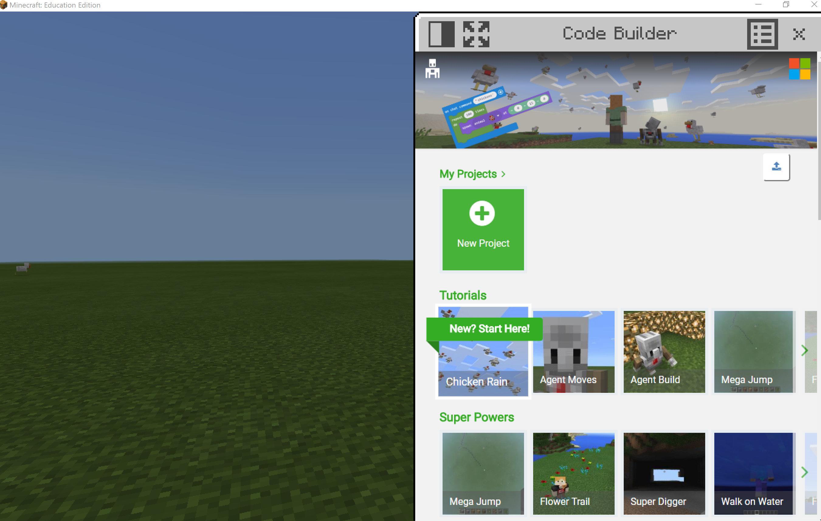
Play through tutorial. Can you make more than chickens fall from the sky? Can you make more than one mob fall from the sky at the same time?
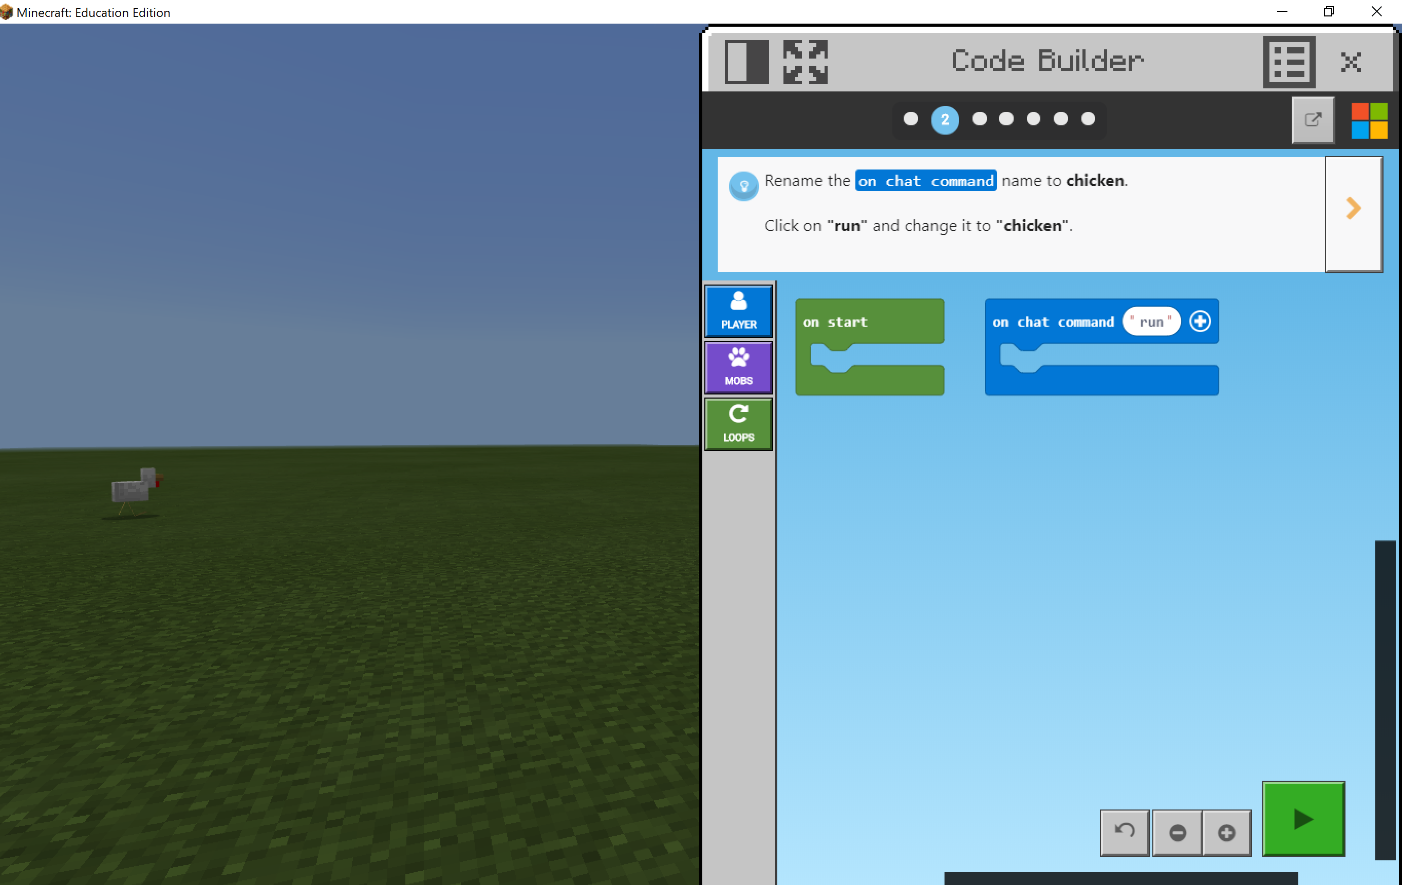
Hint: Click the green “play” button to go back into Minecraft after you have written your code in Code Builder. Press the key “T” on your keyboard to open up chat, and type in your “on chat command” word to execute your code in Minecraft!
Try out the other tutorials.

Want More Minecraft Skills?
Minecraft: Education Edition: Teacher Academy - Microsoft Educator Center
Minecraft: Education Edition Teacher Academy is a series of three sections and eleven courses which focus on the use of Minecraft: Education Edition as a teaching and learning tool designed to support strong pedagogical practices in the learning environment. The courses are divided into three sections of topics intended for beginner, intermediate, and advanced users. At the end of this Learning Path, you will become a Minecraft Certified Teacher and receive the badge.
Path participants will learn:
- Basic mechanics of downloading, setting up and logging into Minecraft: Education Edition.
- In-game play by exploring movement within the game as well as learning the process for placing and breaking blocks
- In-game features to use as tools for assessment and feedback
- The process of creating build challenges utilizing game-based strategies
- Key features of World Management and Classroom Settings
- Tips on classroom management and readiness
- An understanding of basic in-game coding
- Skills that allow for learner collaboration, creativity, and communication
- How to incorporate engineering practices
- Chemistry and Science in-game functionality
- How the game supports learner inquiry and curiosity

